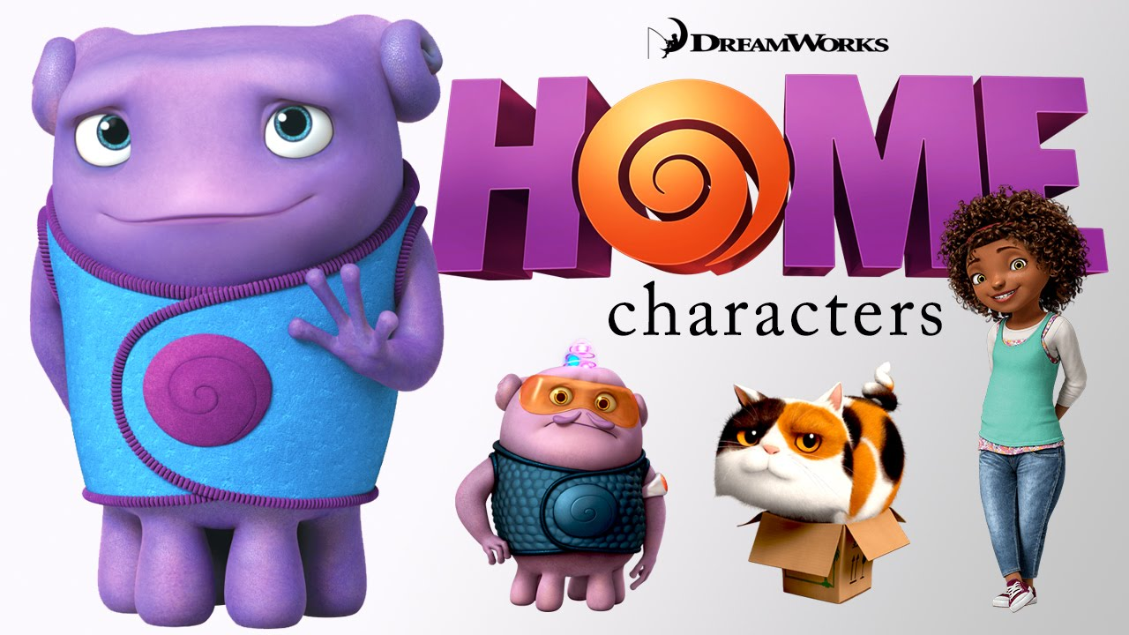

On the run from their enemy, the planet-destroying Gorg, the Boov find Earth a suitable place to call "home". Led by Captain Smek (Steve Martin), they commence their "friendly" invasion of the planet, relocating the humans, whom the Boov deem as simple and backwards, to other parts of the planet while the Boov inhabit their homes in a quick and bloodless conquest. One of the Boov, named Oh (Jim Parsons), is a more excitable, freethinking member of the species, who decides to invite the Boov to his apartment for a housewarming party, despite the race's antipathy towards him. Not far from Oh is a fourteen year old^{[6]} girl named Tip (Rihanna), who drives away through her home city to find her mother Lucy (Jennifer Lopez) after being separated from her during the invasion, leaving her with only her calico cat Pig and fueling her hatred for the Boov.
Oh runs into the street to meet up with a Boov cop named Kyle (Matt Jones), who, like the rest of the Boov, refuse to befriend him. Oh invites him to the party and decides to send a mass invite to every Boov on Earth. However, the "send all" button he pressed actually sends the invite to absolutely every alien race in the entire galaxy including the Gorg. Everyone, aggravated with Oh for revealing their location to the enemy, starts chasing him down. Oh runs into a convenience store to hide just as Tip and Pig enter the same store to grab supplies. They come across each other, and after Tip's car fails to start, Oh transforms it into a fantastical, hovering craft to continue transportation. Oh hitches a ride with Tip when he promises to help her find Lucy, but unfortunately, they must to go to the Boov Command Center in Paris and locate her from there.
After reaching the Boov Command Center, which is in the now-floating Eiffel Tower, Oh manages to get into his account, and deletes the message just a second before it reaches the Gorg. He then plugs in Tip's brain to help her find Lucy. They eventually trace her location to Australia, where she is also looking for her daughter. The other Boov then find the two and try to "erase" Oh, while Tip grabs the gravity manipulation system and flips it over, causing the whole Tower to tilt upside down.
As Oh and Tip head off to Australia, they see other Boov riding by them in fear, and realize that a Gorg ship is close behind them. Tip and Oh manage to knock it down, but in the process a chunk of it hits them and they lose their slushie fuel. They come across the fallen Gorg ship and find out that it is actually a drone. Oh recovers a special chip and uses it to get their car up and running.
Tip and Oh make it to Australia and see the Boov evacuating to their mothership. When they land the car, Tip starts to run for her mother, but Oh insists on evacuating with the other Boov instead. Tip gets angry at him for trying to break the promise again, and she declares that they were never friends. Heartbroken, Oh returns to the ship. The Gorg mothership comes close to the Boov ship, but Oh pulls out the Gorg chip and uses it to fly the ship further away from the Gorg. The Boov become astonished at Oh's plan, but Smek becomes upset and reminds everyone that he is the captain. However, after Oh tells the Boov what he learned from Tip, Kyle grabs Smek's "shusher" (a scepter with a rock on top of it) and gives it to Oh, declaring him the new captain.
Tip rushes aimlessly around the city to find Lucy, but no one can help her. Oh returns to her side and helps her track down Lucy. The mother and daughter finally reunite and thank Oh. The Gorg mothership descends upon the planet, and Oh realizes that they want the rock on the shusher, since Smek had previously stolen it from them. Oh runs to the ship to try and get its attention, locking Tip and Lucy in the car for safety. Tip breaks out of the car and shines a light in the Gorg Commander's face to bring his attention to Oh as he holds the rock up. The Gorg Commander (Brian Stepanek) halts the ship as it crunches down on the ground, with Oh in its path. Tip rushes to rescue him, but Oh is seemingly crushed beneath the machine. It backs up and Oh is revealed to be unharmed. The Gorg Commander emerges from his armor to show that he is actually a harmless starfish-like creature. Oh returns the rock to him, which turns out to be a container for millions of developing Gorg larvae; the next generation of Gorg, revealing that the Gorg Commander had been the last of his kind, alone and almost extinct. He thanks Oh and departs.
Two weeks later, the humans have returned to their original homes, and Oh finally gets to have his party at his apartment, with both humans and Boov in attendance. Tip plays her music and gets the rest of the Boov to experience dancing for the first time, while other Boov, including a reformed Smek, party on the moon, and thousands of ships from other planets, including the Gorg, head to Earth for Oh's party upon receiving his invite.

Good luck dear student

